What are your personal goals and objectives in addition to the course objectives?
This could be for Studio, BIT or general career progression

One of my primary goals while studying the BIT at Polytech is to refine my ability to teach myself new technical skills. I think this is the single most important thing to take away from the BIT course because the industry has historically changed so rapidly, but is quickly becoming an entirely new field with the constant improvement of AI models. I have a sneaking suspicion these efforts will ultimately be for nothing but for now that is what I’m primarily focusing on.
For Studio specifically my main focus is to improve my team communication and contributions as much as possible. It is the main area that I’m letting myself (and my team) down.

What has gone well this semester? What are your strengths?
My strengths, particularly in relation to Studio, are my ability to empathise and relate different kinds of people. This includes different age groups, technical ability and cultural background. I think this is because many of the jobs I’ve previously had required a high level of empathy to be successful. I think this semester the work I’ve completed for Embedded Systems have gone well!

What could have gone better and how? What would you do differently next time?
If you could replay the semester over again, what improvements would you make?

I could certainly have contributed more to the team based tasks we’ve been given throughout the semester, especially Github presence and participation on stand-up meetings. These two things are absolutely the areas I would improve on if I were able to replay the semester over again. Class attendance again is something I definitely have room to improve on and is something I’m committed to improving.

What are the next steps to take? What is your plan for further self-development?
The most important step to take is a much heavier focus on team participation, I don’t want to be the ‘Ernie’ in whatever team I work with… At this point I certainly am.

What barriers to your success exist? How do you plan to deal with them?

I find myself struggling with a lack of motivation, I think in particular because I feel like this industry (and likely most other industries) is about to become entirely irrelevant. I think there are certain things that could prevent this, but as it stands now I am fairly certain even getting a job in a tech related industry by the time I graduate will be extremely difficult, if not just impossible. I also procrastinate a lot and find myself leaving a lot of things to the last minute. This is entirely a personality fault and something I’m actively working on.

What is not clear or is uncertain?
In Studio, for BIT, at Polytech etc

I think the courses across the board that I’ve done so far are quite clear, well structured and especially the in-class teaching is excellent. I guess the uncertainty I have is what I mentioned previously, employment opportunities in the industry in the future. One thing I would like to know is how instructors at the Polytech would tackle this issue, because I feel like it’s likely a common sentiment.

What evidence do you plan to use to demonstrate your completion of the objectives?
(For the mid-semester PDR you will have only completed some of the objectives. Just bring evidence of those ones)

I plan to use evidence of stand-up meetings conducted in our new Studio groups, as well as screenshots of contributed code snippets, pull requests and code reviews.
Example of pull request completed.
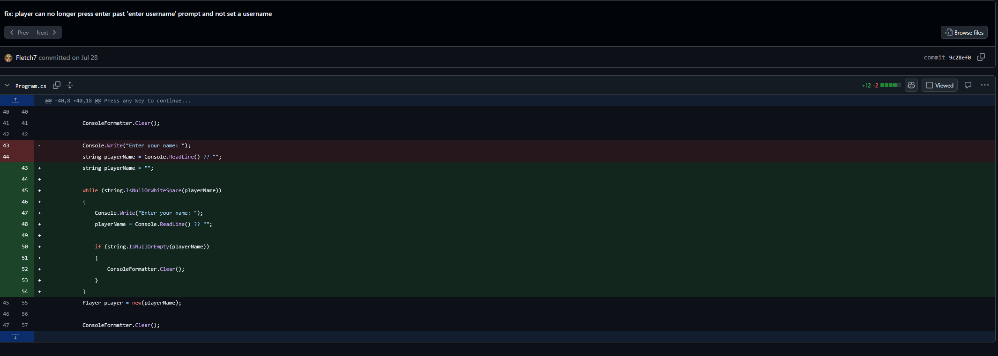
Example of code review following the coding review standards set out by the group in the our wiki.
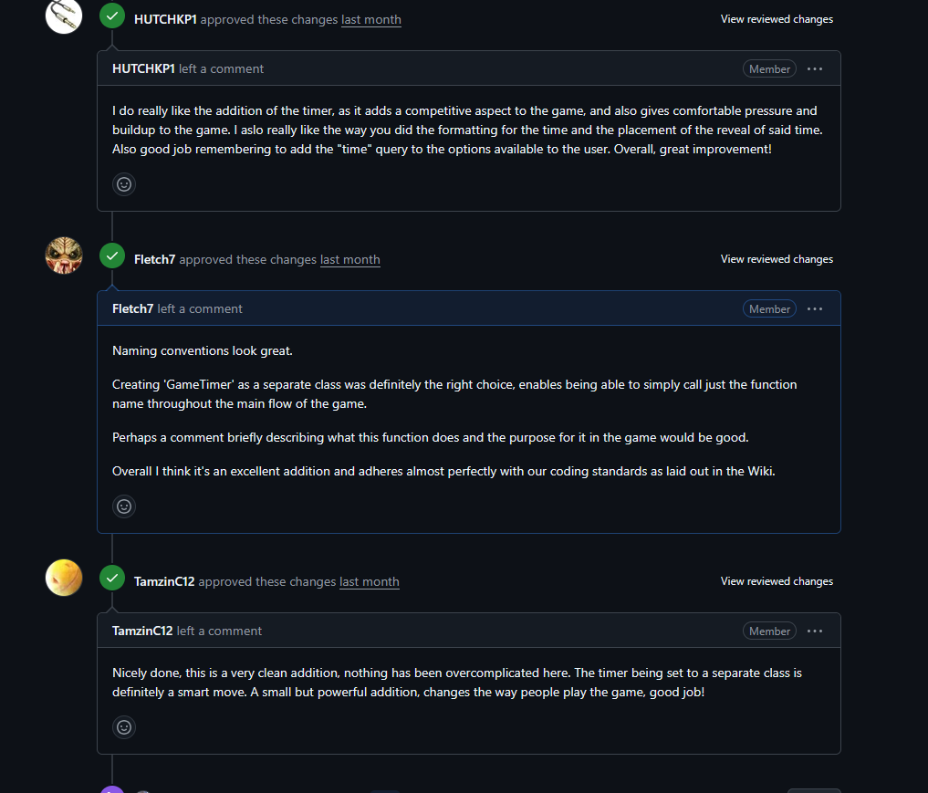

2.3 Have an active presence on GitHub
Demonstrate that you communicated well and often on GitHub: always made good Pull Requests for your features, wrote thorough code reviews, described Issues properly etc.

I have definitely had the smallest presence on Github (except for Hank) of the group. I aim to change this in the second half of this semester.

1.2 Use Design Thinking techniques to plan a user-centric project
Give examples that show how you used Empathise, Define, Ideate, Prototype, Test techniques to ensure the customers would get what they actually need.

Just some basic examples of how I plan to implement the user centric design model.

